CA2

Database Systems

Submitted to

**Jennifer Byrne**

Submitted by

**Pratyush Kakkar**

(20022933)

Date

24th February, 2025

Table of Contents

**Travel Agency Database System 1**

**Background & Scope 1**

**Entity Relationship Diagram 3**

**Potential Security Threats & Cloud Solution 5**

**1. Data Breaches & Unauthorised Access 5**

**2. Loss of Data Integrity & Availability 5**

**3. Insecure Payment Processing 6**

**Strategies to Diminish Future Cloud Outages 7**

**1. Multi Cloud / Region Redundancy 7**

**2. Disaster Recovery Planning 7**

**3. Incident Response and Communication 7**

**4. Third Party Risk Management 7**

**5. Zero Trust Model 7**

**Bibliography 8**

Figure 1 Entity Relationship Diagram 4

# Travel Agency Database System

## Background & Scope

The Travel Agency Database System is designed to manage and streamline the operations of a travel agency, focusing on customer bookings, package deals, payments, travel arrangements, destinations, hotels, and activities. The system aims to provide a comprehensive and efficient way to handle the various aspects of travel planning and customer management.

The travel agency operates by offering various travel packages to customers, which include travel arrangements, accommodations, and activities. Customers can book these packages, make payments, and provide comments or special requests. The agency needs to manage customer information, booking details, payment records, and the specifics of each travel package, including destinations, hotels, and activities.

*An example of the system would be:*

*Jennie is planning a trip to the Himalayas with the travel agency. She provides her personal details, and the system assigns her a unique ID to manage her information efficiently. Jennie selects the "Himalayan Explorer" package, which includes trekking, accommodations, and guided tours. Her booking is recorded, and she adds a special request for vegetarian meals during her trip. Once the booking is confirmed, Jennie makes the payment, and the system records the details, including any discounts applied.*

*The travel agency organizes Jennie’s travel arrangements, including flights and transfers, to ensure she reaches her destinations on time. Her trip includes stops in Kathmandu and Lukla, where the agency has arranged comfortable hotel stays for her. Throughout her journey, Jennie will enjoy a variety of activities, such as trekking to Everest Base Camp and exploring local monasteries, all carefully planned and coordinated by the agency.*

## Entity Relationship Diagram

The database system encompasses several key entities and their relationships:

1. **Customer**: Stores customer information, including first name, last name, phone number, and email. Each customer is uniquely identified by a CustomerID.
2. **Booking**: Manages booking details, linking customers to specific travel packages. Each booking has a unique BookingID and includes information such as the booking date, total cost, and any customer comments.
3. **Payment**: Tracks payment details for each booking. This includes the payment date, method, any discounts applied, and the amount paid. Each payment is linked to a specific booking via BookingID.
4. **PackageDeals**: Contains information about the travel packages offered by the agency. Each package has a unique PackageID and includes a description, price, and details about whether it supports split payments and the validity period.
5. **Travel**: Manages travel arrangements for each package, including the travel operator, type of travel, departure and arrival details. Each travel arrangement is linked to a specific package via PackageID.
6. **Destination**: Stores information about the destinations included in the travel packages. Each destination has a unique DestinationID and includes details such as name, location, and description.
7. **Hotel**: Manages hotel information for each destination. Each hotel has a unique HotelID and includes details such as the hotel name, street address, and phone number.
8. **Activity**: Tracks activities available at each destination. Each activity has a unique ActivityID and includes details such as name, location, description, and cost.

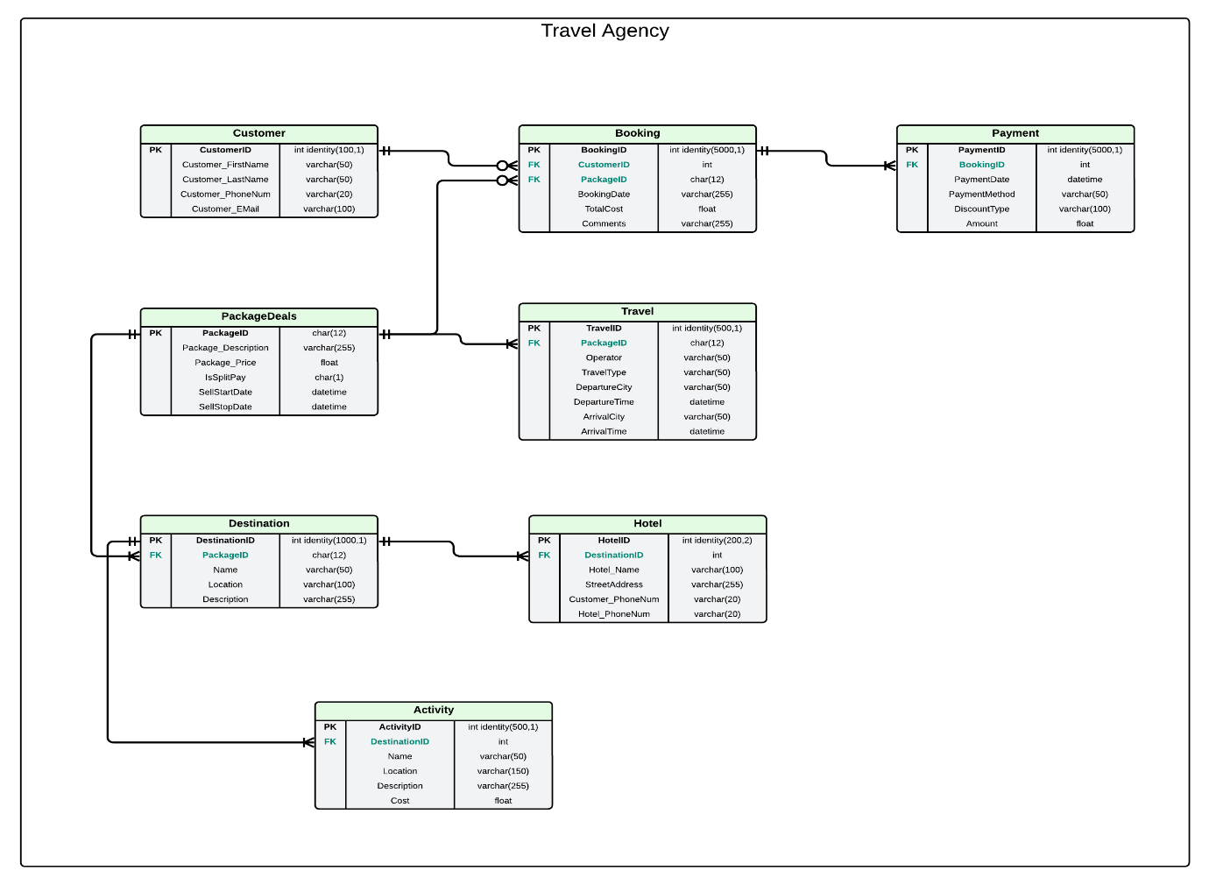

Figure 1 Entity Relationship Diagram

## Potential Security Threats & Cloud Solution

The main threats to the Travel Agency Database System and their solution with Microsoft Azure are as follows:

### 1. Data Breaches & Unauthorised Access

The database stores the **personal details** of the customers such as Name, E-mail and Phone number as well as **financial data** such as Payments, Amount and Methods.

Hackers can exploit weak authentication mechanisms or people working at the Travel Agency to steal data for **fraud** or **identity** **theft**.

Solution:

These can be solved using Microsoft Azure **Entra ID** which implements **Multi Factor Authentication** (MFA) that prevents unauthorised access even if the passwords are compromised. Similarly with Role Based Access Control, administrators can limit the access to only the data that the employees need. *(Barclayn, Dec 2024)*

With Azure’s **Encryption of Data** at rest and in transit customer details are protected.

*(Msmbaldwin, Apr 2024)*

### 2. Loss of Data Integrity & Availability

The customer payment records could be corrupted or deleted by **accidental deletion**, software bugs or Malicious attacks like ransomware.

This may lead to the customer trust being impacted because of **double payments, incorrect balances**, or **lost financial transactions**.

**Employees** with **unmonitored access** can also modify or delete data.

Solution:

Azure SQL Database generally creates full backups every week and differential backups every 12 or 24 hours. Such regular automatic **backup** ensures quick restoration to **recover** from accidental deletion or ransomware attacks. *(WilliamDAssafMSFT, Feb 2025)*

### 3. Insecure Payment Processing

If the payments are processed without **proper encryption** attackers can intercept payment details during transmission.

A **lack of firewalls** makes it easier for hackers to manipulate transactions.

Cybercriminals could **alter payment records**, making the system show incorrect instalments paid or unpaid, leading to **financial losses** for the business.

*(Byrne, 2025)*

Solution:

SQL Databases in Azure are protected by **firewalls** by default. To allow resources to connect to the Database the Server Admin needs to allow or give permission to only specific **trusted** **IP addresses**. *(VanMSFT, Jan 2024)*

For the payment data, **Azure Key Vault** can be used which securely stores and manages the encryption keys. This prevents attackers from being able to intercept this data.

*(Baldwin, Sep 2024)*

## Strategies to Diminish Future Cloud Outages

In order to mitigate any further Cloud Outages, organisations should focus on the following:

### 1. Multi Cloud / Region Redundancy

Critical applications should be deployed across multiple cloud providers (AWS, Azure, Google Cloud) or different regions (London, Delhi). This ensures **Workload Distribution** especially during public cloud outages. *(Aggarwal, Dec 2024)*

### 2. Disaster Recovery Planning

Companies should ensure **Regular Backups** take place stored in diverse locations as well as test recovery workflows.

**Regular drills** should also be conducted to validate the recovery protocols and identify gaps so the teams are prepared for the real world scenarios. *(Nnaik, Jul 2024)*

### 3. Incident Response and Communication

Develop **Incident Response Plans** with predefined roles, escalation paths, and communication protocols to stakeholder.

Organisations should also partner with the vendors to be on top of the **Real Time** updates aligned with their needs.

### 4. Third Party Risk Management

Thoroughly **Evaluate** cloud providers’ disaster recovery capabilities and security practices to avoid hidden vulnerabilities.

### 5. Zero Trust Model

To safeguard the data during Outages it is essential that organisations implement strict access controls and encryption. *(Harpham, Dec 2024)*

# Bibliography

1. Dilts, B. and Sun, K. (2010) ‘Lucidchart 2025’. Lucid Software.

<https://www.lucidchart.com>

1. Byrne, J. (2025) ‘Database Administration’ [PowerPoint Presentation]. *B7IS121: Database Systems*.

<https://elearning.dbs.ie/mod/resource/view.php?id=1646299>

1. Barclayn (19 Dec 2024) *What is Microsoft entra ID? - microsoft entra*, *Microsoft Entra.*:

<https://learn.microsoft.com/en-us/entra/fundamentals>

1. Msmbaldwin (26 Apr 2024) *Azure encryption overview*, *Microsoft Learn*.

<https://learn.microsoft.com/en-us/azure/security/fundamentals/encryption-overview>

1. WilliamDAssafMSFT (3 Feb 2025) *Automatic, geo-redundant backups - azure SQL database*, *Automatic, geo-redundant backups - Azure SQL Database* . <https://learn.microsoft.com/en-us/azure/azure-sql/database/automated-backups-overview?view=azuresql>
2. VanMSFT (26 Jan 2024) *Secure a database - azure SQL database*, *Secure a database - Azure SQL Database* .

<https://learn.microsoft.com/en-us/azure/azure-sql/database/secure-database-tutorial?view=azuresql#create-firewall-rules>

1. Baldwin, M. (11 Sep 2024) *Azure key vault overview - azure key vault*, *Azure Key Vault Overview - Azure Key Vault*.

<https://learn.microsoft.com/en-us/azure/key-vault/general/overview>

1. Aggarwal, S. (2024) *Understanding cloud outages: Causes, consequences, and mitigation strategies*, *TechAhead*.

<https://www.techaheadcorp.com/blog/understanding-cloud-outages-causes-consequences-and-mitigation-strategies/>

1. Nnaik (2024) *Real-time Cloud Outage Recovery Management Strategies: CMIT Solutions Tribeca*, *Tribeca, NY 1166.*

<https://cmitsolutions.com/tribeca-ny-1166/blog/real-time-cloud-outage-recovery-management-strategies>

1. Harpham, B. (5 Dec 2024) *7 risk mitigation strategies for the cloud*, *RenovaCloud*.

<https://renovacloud.com/en/7-risk-mitigation-strategies-for-the-cloud>